Assignment Date | 19 September
Student Roll No | 1901108
Student Name | Kishore Kumar A
Marks | 2

1.Create a Bucket in IBM object storage.

2. Upload an 5 images to ibm object storage and make it public. write html code to displaying all the 5 images.

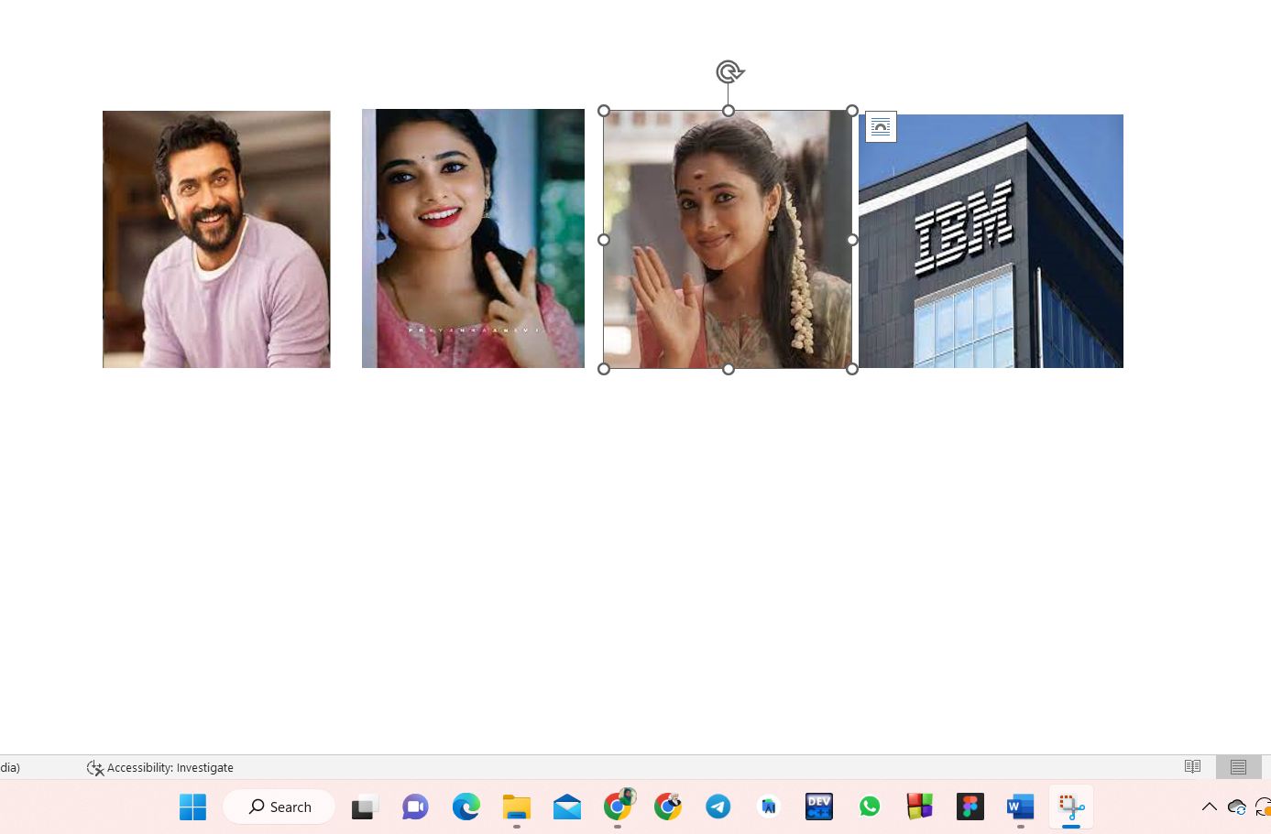

3. Upload a css page to the object storage and use the same page in your HTML code.

Style.css
img{
text-align: center;
height:250px;
width:250px;
}

Assignment3.html
<!DOCTYPE html>
<html lang="en">
<head>
<meta charset="UTF-8">
<meta http-equiv="X-UA-Compatible" content="IE=edge">
<meta name="viewport" content="width=device-width, initial-scale=1.0">
<title>Document</title>
<link rel="stylesheet" href="https://vishwa7.s3.us-east.cloud-object-storage.appdomain.cloud/style.css">
</head>
<body>
<img src="https://vishwa7.s3.us-east.cloud-object-storage.appdomain.cloud/img1.jpg" alt="">
<img src="https://vishwa7.s3.us-east.cloud-object-storage.appdomain.cloud/img2.jpg" alt="">
<img src="https://vishwa7.s3.us-east.cloud-object-storage.appdomain.cloud/img3.jpg" alt="">
<img src="https://rakesh87.s3.us-east.cloud-object-storage.appdomain.cloud/img5.jpg" alt="">
<img src="https://vishwa7.s3.us-east.cloud-object-storage.appdomain.cloud/img4.jpg" alt="">
</body>
</html>

4.Design a chatbot using IBM Watson assistant for hospital. Ex: User comes with query to know the branches for that hospital in your city. Submit the web URL of that chat bot as a assignment

5. Create Watson assistant service with 10 steps and use 3 conditions in it. Load that script in HTML page.

